Process and Procedure Names:  - Process: IT Management Operating System  - Procedure: HUE within IT Waterfall/Agile Projects | Work Instruction Name:  Experience Diagramming | Effective Date: 20-Mar-2017
Work Instruction Owner:  Tobias Komischke | Work Instruction Name:  Experience Diagramming | Revision Date: 08-Dec-2017

Purpose

Understand and document the stages and touchpoints a user encounters in his/her end to end user journey with a Honeywell offering. HUE training is a prerequisite: Experience Diagramming Training.

Scope

This work instruction is for executing experience diagramming, which involves both journey mapping and touchpoint analysis.

Work Instruction Activities

Step # | Description | Owner (Role) | Details (e.g. screenshots, charts, etc.)
 | Identify participants for the experience diagramming work session, e.g. project manager, SMEs, users. | Project Manager
 | Invite participants to a work session. This meeting should be ideally face-to-face. If not possible, the next best solution would be a lync call with video sharing. | Project Manager
 | In meeting, list all high-level stages that a user who is highly impacted by the offering (identified during stakeholder mapping) goes through sequentially in his/her end to end engagement with the Honeywell offering.  Document the stages horizontally and in sequence. | HUE representative | Example stages:  - Select device  - Place order  - Get approval  - Receive device  - Configure device  - Enroll device  - De-commission device  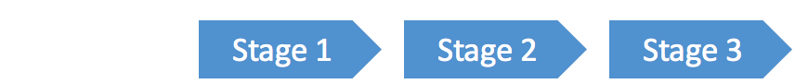  Feel free to use the Experience Diagram template.
 | For each stage, list all activities that a user is carrying out.  Use sticky notes (digital notes in case of remote working session) to document activities and place them beneath each associated stage. | HUE representative | Example activities for “Select device” stage:  - Open GetIT website portal  - Select phone ordering option  - Select device model  - Select color  - Select carrier  - Select data plan  - Submit request  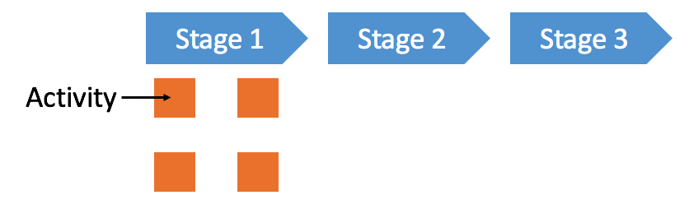
6. | For each stage and/or activity, list every touchpoint (person, place or thing) that a user encounters.  Use sticky notes (different color than activity stickies) for documentation and place them beneath the associated stage and/or activity. | HUE representative | Example touchpoints:  - IT support portal  - IT support app  - Intranet  - Get IT Portal  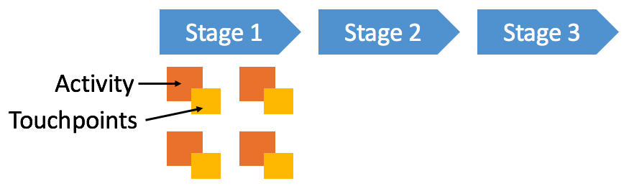
7. | Prioritize stages, activities and touchpoints based on business and user impact.  - Use stickers to signify high-priority elements  If online meeting, use Powerpoint shapes (e.g. a star). | HUE representative | Example prioritization criteria:  - User impact  - Pain point for user  - Hero experience for user  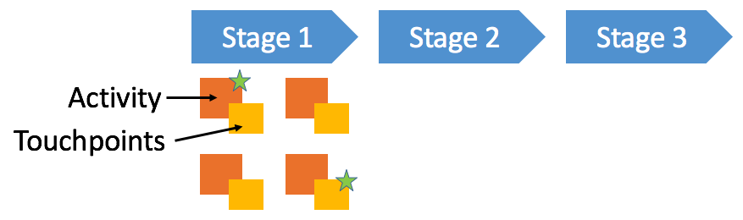
8. | If applicable, transfer the experience diagram into an electronic version, e.g. Powerpoint | HUE representative | Example of experience diagram:  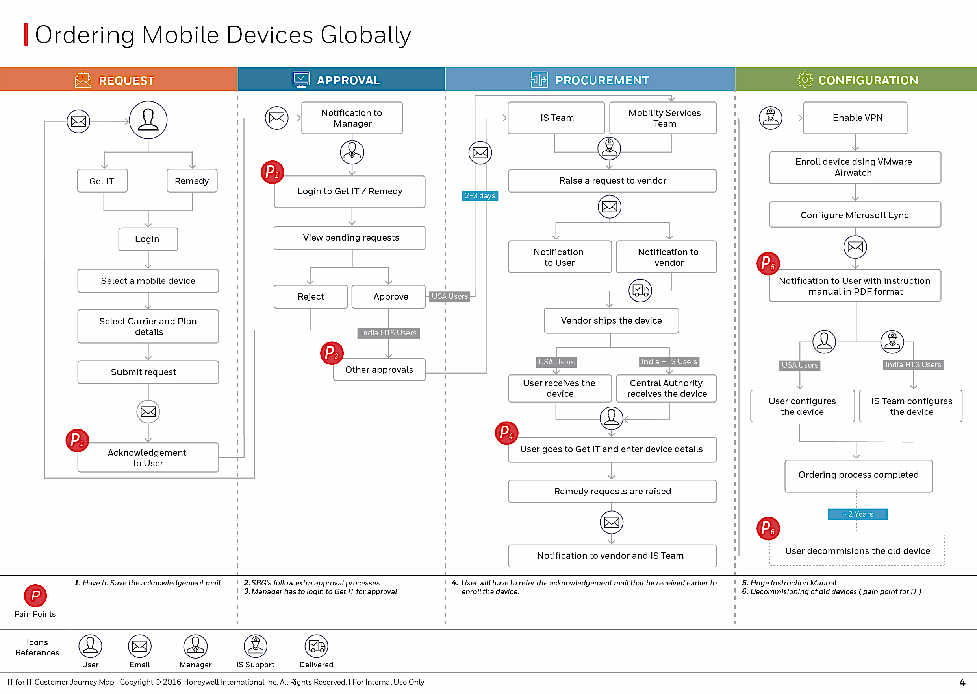
9. | Store electronic experience diagram as project artefact on project share drive | HUE representative

Enforcement

Failure to adhere to published policies, processes, procedures, work instructions and standards will be evaluated on a case by case basis and may result in disciplinary action. Published policies, processes, procedures, work instructions and standards are also subject to audit by Honeywell Corporate Audit and external auditors for verification of compliance.

Version Control and Review Frequency

This Procedure is to be reviewed at minimum annually.

Date Last Reviewed: 08-Dec-2017
Reviewed By: Tobias Komischke, IT HUE Leader

Version # | Effective Date | Section(s) | Description | Author | Content/SME  Approval | Work Instruction Owner Approval
1.0 | 20-Mar-2017 | Full document | First version | Tobias Komischke | Madhumita Gupta | Tobias Komischke
2.0 | 01-Nov-2017 | All | Incorporated new role of HUE representative and aligned to approved HUE process integration with waterfall/agile Software process | Madhumita Gupta | Tobias Komischke | Tobias Komischke
2.1 | 08-Dec-2017 | All | Formatting edits based on Process Change Register requests | Tobias Komischke | Madhumita Gupta | Tobias Komischke
*Process Owner, Process Governance and External Compliance approvals are through the automated tool

